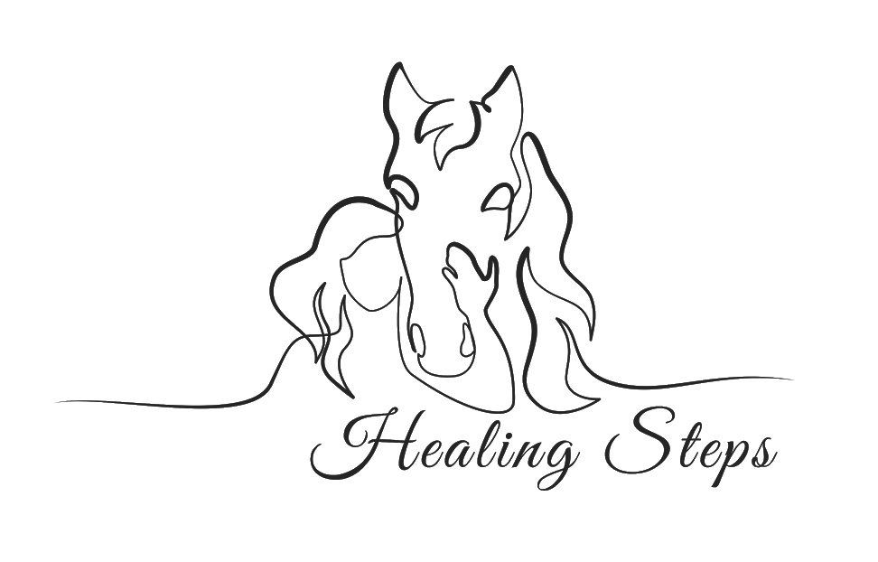
VOLUNTEER HANDBOOK

Healing Steps- Equine Centered Therapy LLC.
(360) 771-3556
Email: Kelsey.healingsteps@gmail.com
Physical Address: 12608 Ne 299th Street Battle Ground, WA 98604
Healingstepstherapy.org

Contents

Healing Steps Mission Statement & FAQs
Volunteer Expectations
Cancellation Policy and Weather related Cancellations
Recommended Attire
General Barn Safety Guidelines
Confidentiality & HIPAA Policy
Nondiscrimination Policy
Site Specific Hazards
Hazards specific to use of Equines

Mission:
Healing Steps is dedicated to improving success in daily life through the skillful partnership of occupational therapy and horse related activities.

FAQ:

What do volunteers do at Healing Steps?

Volunteers are needed for side-walking during therapy sessions, assisting the therapist in gathering materials, helping to prep the horses for sessions, and other miscellaneous jobs around the barn.

How many hours do you want volunteers to be there for?

We are grateful of any time you have to donate. If you’d like to assist in 5 sessions for the day or just one, we are thrilled to have you joining us and assisting our therapy team.

How long do volunteers have to commit to volunteering for?

We love volunteers to commit to a minimum of 5 weeks due to the time it takes to train you to properly and safely assist in the therapy sessions! It is our hope that our volunteers get as much out of the experience as the clients do in respect to growth, joy, and in building relationships. Our volunteers become an important part of the rehab team and our clients look forward to seeing them at their sessions.

Volunteer expectations

We love and appreciate our volunteers, and we depend on them. If you are signed up to assist for a session, we ask that you give no less than a 24 hour notice if you are unable to make it. This is for the safety of our clients so that we may fill the spot to ensure the safest experience possible. We expect volunteers to arrive 10 minutes prior to the start of the scheduled session and check in with therapist for ways to assist in preparing for the session. We ask that you come to each session with patience and excitement, as we strive to create the most therapeutic environment possible for our clients. We ask that our volunteers communicate with the staff when they have a question or a concern impacting their ability to assist with the therapy at Healing Steps.

Weather related cancellations

Healing steps takes every possible measure to ensure the safety of our clients, volunteers, and horses. There are times when sessions may be cancelled due to unsafe weather conditions. We follow the Battle Ground School District- South schools in regards to winter closures during snowy/icy weather. Sessions in the summer will also be modified if the temperature in the arena is 90 degrees or above at the time of your session. Healing Steps also monitors air quality reports and may cancel or modify sessions when conditions are unhealthy for clients, staff, and equines.

Recommended Attire

*Volunteers arriving without the required attire will not be allowed to interact with the horses or patients
1. All volunteers must wear appropriate clothing for interacting with both horses and patients including no low-cut shirts, long pants, and weather appropriate clothing.
2. All participants, personnel and parents must be wearing appropriate footwear on site: Closed-toed, and closed-heel shoes are considered to be appropriate.
3. Full length pants are recommended for therapy sessions. Pants with slick surfaces are discouraged.
4. No loose jewelry, dangling earrings and necklaces are not allowed for your safety.

General Barn Safety Guidelines
1. No smoking anywhere on the property
2. All riders must wear a helmet at all times when interacting with the horses. For riders under 18, this includes while riding, and while interacting on the ground.
3. Non-independent individuals, including children under the age of 16, and those requiring other types of supervision to be safe are to be attended by a parent/guardian or other designated adult at all times.
4. No running or screaming on the property during treatment sessions.
5. All siblings/guests of clients must be under adult supervision at all times.
6. Everyone in the barn MUST have proper footwear
7. No hand feeding the horses unless given permission by staff.
8. No loose jewelry (hoop earrings/necklaces)

Non-Discrimination Policy
Healing Steps and Grace Therapeutic Horse Program do not discriminate in it’s staff, volunteers, or clients on the basis of a person’s race, religion, gender identify, sexual orientation, age, national origin, ancestry, marital status, veteran status, or mental/physical disability, or any other status prohibited by applicable law.

Site Specific Hazards
1. Ladders and haystacks are off limits
2. Only staff and trained personnel are allowed to operate the tractor.
3. Horses will frequent the parkinglot area on occasion. We must insist on a 5mph speed limit on site.

Hazards Specific to the Use of Equines
Injuries can be inflicted by a horse in many different ways including but not limited to: biting, kicking, bucking, stepping on a person, and spooking.

In the event of an accident/injury during a therapy session;
- Therapist stops the session or emergency dismounts the client, if needed
- If applicable, therapist begins CPR and first aide and a designated volunteer directs other personnel and participants
- If needed, 911 will be called by volunteer

- Therapist will complete Incident Report Form

Equine Management Philosophy and Horse Care Standards

Horses used on the property will be cared for to the highest of standards. Horses will be fed quality food with proper nutrition proportions to best support their health. Measures will be taken to protect not only the horse’s physical health, but emotional health as well ensuring their needs are addressed on a daily basis.

Horses are regularly exercised and ridden outside of therapy sessions to keep their bodies fit and minds fresh. Horses are limited to no more than 3 consecutive hours of therapy/riding, and a maximum of 4 hours of use per day (of walking/trotting). Horse use will be tracked to ensure no horse is being overused. Horse usage is planned and determined based upon the needs of the clients and the horse.

