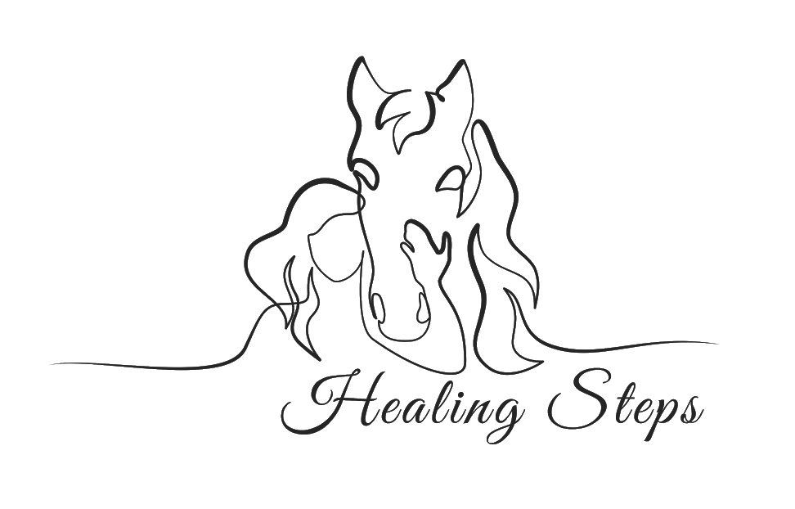
RELEASE AND WAIVER OF LIABILITY
ASSUMPTION OF RISK AND IMDEMITY AGREEMENT

READ THIS AGREEMENT CAREFULLY BEFORE SIGNING IT. YOUR SIGNATURE INDICATES YOU UNDERSTAND IT AND AGREE ON IT’S TERMS. BY SIGNING THIS AGREEMENT, YOU AND YOUR CHILD ARE GIVING UP CERTAIN LEGAL RIGHTS, INCLUDING THE RIGHT TO SUE OR RECOVER DAMAGES IN CASE OF INJURY, DEATH, OR PROPERTY DAMAGES, FOR ANY REASON, INCLUDING BUT NOT LIMITED TO THE NEGLIGENCE OF THE STABLE; IT’S OWNER, THERAPIST, EMPLOYEE, AND AGENTS.

I ____________________________________ on behalf of myself (and my minor/child) _____________________________________________________
Print first and last name Print Child’s Name

I reside at ____________________________________________ in _______________________________________________, ____________, ___________________.
Street address City State Zip

In consideration for allowing me (or my minor child) to handle and ride a horse during therapy, and on behalf of myself, my child or our personal representatives, heirs, next-of-kin, spouses and assigns, I HEARBY:

- Acknowledge that a horse or mule may, without warning or any apparent cause, buck, stumble, fall, rear, bite, kick, run, make unpredictable movements, spook, jump obstacles, step on a person’s feet, push or shove a person, saddles or bridles may loosen or break-all of which may cause the rider to fall or be jolted, resulting in serious injury or death.
- ACKNOWLEDGE THAT HORSE ACTIVITIES ARE INHERENTLY DANGEROUS ACTIVITES and involves risks that may cause serious injury and in some cases death, because of the unpredictable nature and irrational behavior of horses, regardless of their training and past performances.
- Voluntarily assume the risk and danger of injury or death inherent in the use of the horse, equipment and gear provided to me by HEALING STEPS- EQUINE CENTERED THERAPY LLC, hereinafter referred to as Healing Steps.
- RELEASE, DISCHARGE AND PROMISE NOT TO SUE Healing Steps, doing business under its own name or any other name and/or any of it’s owners, officers, volunteers, employees and agents (hereinafter the “releasees”), for any loss, liability, damages, or cost whatsoever arising out of or related to any loss, damage or injury (including death) to my person or property.
- Release the Releasees from any claim that such Releasees are or may be negligent in connection with my riding experience or ability including but not limited to training or selecting horses, maintenance, care, fit or adjustments of riding gear, instruction or riding skills or leading and supervising participants.
- INDEMNIFY, AND SAVE AND HOLD HARMLESS the stable (Grace Therapeutic Horse Program), and Healing Steps’ therapists, volunteers, and agents from and against any loss, liability, damage, or cost they may incur arising out of or in any way connected with either my use of the horse and any equipment of gear provided therewith or any acts or omissions of therapists, or other employees or agents.
- The undersigned expressly agrees that the foregoing release and waiver of liability, assumption of risk, and indemnity agreement is governed by the state of Washington, and is intended to be as broad and inclusive as is permitted by Washington Law (Ride at your own risk) and that in the event any portion of this Agreement is determined to be invalid, illegal, or unenforceable, the validity, legality and enforceability of the balance of the Agreement shall not be affected or impaired in any way and shall continue in full legal force and effect.
- Acknowledge that this document is a contract and agree that if a lawsuit is filed against Healing Steps, it’s owner, employees, agents, or volunteers for any injury or damage in breach of this contact, the Undersigned will pay all attorney’s fees and costs incurred by Healing Steps in defending such an action.

I have read this entire Release of Liability Document. I understand it is a promise not to sue and to release Healing Steps, It’s owner, employees, volunteers and agents for all claims. I have made a free and deliberate choice to sign this Release and Waiver as a condition to Releasees allowing me or my child to participate in any activity involving a horse. I have concluded that the risks involved and the release and waiver of liability is worth participation in equine centered Occupational Therapy.

___________________________________________________________________ _____________________
Signature of Participant or Parent/Guardian if under 18 Date

